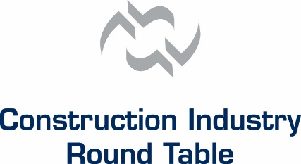
CIRT News
A force for positive change in the design / construction industry

3/31/2015 – 2015 CIRT – ACE National Design Competition Finalists Announced

Today, CIRT announced the three national finalist teams that will compete in the final presentation round of the 9th Annual CIRT-ACE National Design Competition to be held on April 27, 2015 in Washington, DC. A record 46 entries from across the country were submitted and evaluated for top honors in the National Design Competition.

“The quality and level of the entries were the strongest they have ever been in the nine year history of the competition, making the job of the judges all that more difficult,” commented CIRT President Mark Casso. But notwithstanding the challenge, the judges narrowed the field down to the national finalists.

This year the three garnering the coveted right to be named a national finalist were a mix of experienced teams and a first-time finalist that should make for an outstanding final round. The following teams have been chosen to make presentations at the national competition which will be held in conjunction with CIRT’s Annual Spring Meeting:

- ACE North-East Florida, Orange Park H.S./Team Mark-0 for their “Harmony Springs Health Clinic” entry;
- ACE Illinois/Chicago Team 1 for their “Park City” entry; and
- ACE of Frederick, Maryland for their “BRT: Efficient Solutions for Road Transportation Systems” entry

In addition to the finalist, six other teams were recognized as either First Runner-Up ($1,000 award) or Second Runner-Up ($500 award) in each of the three different design challenges or options:

Health Clinic Challenge: 1st Runner-Up - ACE Mentor Program of Central Iowa for “CONNECT-A-CLINIC”;
2nd Runner-Up - ACE Houston/Bechtel for “Meditech Maternity Hospital”

City Centre Challenge: 1st Runner-Up - ACE Mentor San Diego, CA/San Diego H.S. ACE Club Team for “New Imperial Beach”; 2nd Runner-Up - ACE Mentor Michigan/Detroit Chapter for “Gateway Park”

Transportation/Road Systems Challenge: 1st Runner-Up - ACE Mentor San Diego, CA/Southwest H.S. Team for “U.S.-Mexico Pedestrian Crossing Area at the San Ysidro Port of Entry”; 2nd Runner-Up - ACE Greater NYC/Team 30 for “Hunters-Union Tunnel”

Again this year, a special award was given to a non-winning team for the “Best Presentation Boards”. The winner for this year’s competition was: ACE Mentor Program of Miami-Dade County for their “Blurred Lines” entry boards in the Transportation challenge category and they will receive a $250 award. Also, CIRT wishes to recognize and congratulate the greater Houston, TX Affiliate for having the most entries in the competition.

As noted, all of the projects were well done making it a difficult task for the judges to select the national finalists; but in the end, the choices were unanimous as to which entries should be chosen. The Round Table is looking forward to a spirited and exciting final competition on the afternoon of April 27th (4:00PM), in conjunction with the CIRT Spring Conference held in Washington, DC at the Park Hyatt Washington.

