CIRT
National Design and Construction Competition Program
2021

Program Information
Package

When something is important enough, you do it even if the odds are not in your favor.
Elon Musk
Electric Car manufacturer

A Partnership Project with the
ACE Mentor Program of America
and
Chicago Architecture Center

2020 CIRT National Design & Construction Competition Program

AWARDS PROGRAM
The CIRT National Design & Construction Competition maintained, coordinated, and judged by Construction Industry Round Table is intended for ACE Mentor Affiliate team entries. Winning teams, on behalf of their Affiliates, will receive a monetary award that can be used use for any purpose to support the operations, programs, grants, and/or needs of the Affiliate.

PROGRAM SPECIFICS
- Sponsors: CIRT and on voluntary basis individual CIRT firms.
- Collaboration: The program is coordinated with the ACE Mentor Program of America (ACE) and the Chicago Architecture Center (CAC) to provide an online digital platform to conduct the competition.

- Theme for the Program: Celebrating the innovations and contributions the design/construction community makes to the quality of American life, while understanding the issues and challenges the industry faces to deliver on this legacy.

- Award Approach: Any ACE Mentor Affiliate/Chapter can volunteer to participate in the CIRT National Design & Construction Competition, which uses project challenges adapted and/or modified to accommodate the competition’s parameters. The true goal is to judge the ability of the students to make a reasoned, coherent, well thought out, clear presentations on their team’s design/construction approaches that are realistic and responsive to the project’s objectives within time/budget/constructability constraints, etc.

- Definition of a Team: Entries to the competition must from teams comprised of at least three or more students. The intent is to encourage group dynamics requiring assignments, compromise, and/or consensus building.

- Multiple Teams from One Affiliate: CIRT ardently requests and recommends that Affiliates with more than one team contemplate submitting entries in the different challenges rather than multiple ones in the SAME category. This will greatly increase the value of the competition and improves the odds of having one of the teams among the recognized entries when spread amongst the various challenges.
- Program Schedule: The annual event is announced in the early fall and officially begins in January concluding with the final round in late April or early May: where the winner(s) will be selected and announced. [Interim milestone and final submittal dates are included in this competition package].

- Program Awards: CIRT will present prizes for the top three national finalists ($5/3/2K) plus prizes for runner-up entries. In addition, CIRT will provide a logistical/travel expense stipend (approximately $1,000 per team) to apply to costs associated with attending the final round as the Affiliate/Chapter best determines.

PRESENTATION MATERIALS
The presentation MATERIALS submitted for the competition (will be retained by CIRT) AND are extremely important as THE basis to make the initial cut to the three finalists. [The online submittal must be summarized in a maximum of two ‘virtual boards’]. The entry virtual boards therefore must be clear, concise, complete, and well thought out with sufficient and compelling information to stand independently from any written narrative or report. [The judges are looking for clarity, understandability, constructability, completeness, flow of ideas and how the proposed solution realistically and fully meets the precise elements of the challenge].
“Virtual Boards” (limited to two) can include: a brief written explanation describing the context and thinking behind the scheme; as well as photographs (of the site, 3D model, etc.). No specific drawings or scales are prescribed, but the presentation must convey the ideas underlying the design (whether a building or not), its overall forms and spaces, its character and atmosphere. Narratives addressing the design process (as described below), should be on or presented as part of the boards to the degree it helps clarify and enhance the entry.

FINALIST LOGISTICS
IF YOUR TEAM becomes a FINALIST: Physical Boards MUST BE CREATED (a maximum of two, approximately 841mm x 594mm) mounted on two A1 lightweight boards. These boards MUST BE identical to what was submitted online as “virtual boards.” [Finalist will also be required to provide a digital copy of their entry].
REGISTRATION
ALL teams MUST complete and submit the “Registration Application Form” online at the time their entries are “officially” submitted. [FAILURE TO PROVIDE THIS FORM MAY RESULT IN NOT BEING JUDGED IN THE COMPETITION]. The registration form is critical for the competition to maintain contact with the teams and to establish identification of the various entries with their authors. Thus, the forms must accompany the entry PERIOD! [PLEASE NOTE: The name of your Affiliate/Chapter is the ACE recognized entity for your area – NOT the name of your sponsors, mentors, firms, student group or school].

DESIGN PROCESS
The following questions are representative of the type of information that would be expected along with the design concepts, renderings, etc. (Please note: Jurors will consider the summaries of your replies to these questions when presented as part of your “virtual board” ENTRIES.)

Question A: Define and/or describe the problems/challenges you faced when deciding on the project you chose to do for the competition.

Question B: Thoroughly describe your process, in writing and through visuals (e.g., sketches, renderings, stepped process, before and after, budgets, timelines, workflow, etc.) that specifically and realistically meets the PRECISE or exact nature of the challenge and/or the client goals/needs.
Question C: Explain how your approach is an appropriate, innovative solution that realistically responds to the precise project challenges (including use of materials/construction methods, etc.). Explain how your entry is different from other approaches or processes, if such is the case; and/or meets budgetary constraints, timeline issues, or other construction challenges.

Question D: Describe any social/ecological or otherwise beneficial qualities of your solution. (For example, is it universally applicable? Is it environmentally friendly? Does it use cost-effective or recyclable materials? Etc.?)

Question E: Describe what you learned from this competition.

DESIGN ASPECTS/CONSTRUCTION ELEMENTS
The following design/construction aspects will be evaluation criteria, and should be explained where appropriate:

􀂃 site selection and its context (built and/or natural) – before and after
􀂃 constructability (structural challenges, materials, schedules, textures, colors, etc.)
􀂃 strategy for sustainability (resulting from design and construction decisions)
􀂃 surrounding landscape/external spaces, etc.
􀂃 life and activities, in and around the building, including the qualities of enclosed spaces showing furniture, fittings and finishes (where needed or appropriate to the design competition selected).

JUDGING
The panel of judges will be mainly compromised of CIRT member CEOs of the leading design and construction firms and groups in the United States. As such, the overall theme or evaluation criteria for the competition is one founded on the practical aspects of the profession, particularly with respect to constructability, use of materials, meeting deadlines, workflow, and establishing realistic/reasonable expenses or budgets. More important than the actual design solution, is the methods and processes used to arrive at a solution. Fundamentally, the spirit of this competition is one of design AND construction. During the final round, great weight will be given to the ability of the ACE students (i.e. their ONE selected representative) to articulate a clear, comprehensive, coherent, and cogent presentation that persuades the judges that his/her team has the winning entry most responsive and complete with respect to the challenge goals. (Preparing the student representative is part of the overall process that the other team members will receive benefit from as well).

TIMELINE
The preliminary round will be conducted through the CAC online digital platform. All entries and materials must be entered through this medium so that they can be judged accordingly. The FINAL ROUND will be held in conjunction with the CIRT spring national conference in Washington, DC. TEAMS from ACE Affiliates/Chapters that wish to participate in the national competition must comply with the following time schedule:

- March 17, 2021 (DEADLINE) – All entries must be OFFICIALLY submitted as required by the CAC online platform process [DEADLINE: is (11:59pm) in your time zone on the 17th of March].

- March 29, 2021 – Preliminary results will be announced, with Finalists being notified and plans made to bring a representative(s) from each team to Washington, DC.
- April 5, 2020 – Finalist teams will need to have made their hotel reservations in DC. [The finalists will be provided precise hotel/logistical information upon being selected. The stipend will be available for each team to be used to help cover cost to attend the final round based on need, etc. from the requests of the teams].

- April 26, 2020 – Finalists present to the CIRT Panel of Judges. [Exact information on date, time, and place will be provided finalist].

Program Logistics
The national competition will use a digital platform in collaboration with the Chicago Architecture Center (CAC) to conduct the process. All materials must be submitted to the platform with an official entry to be judged. The preliminary rounds will be determined by what is submitted to the platform as summarized on a maximum of two “virtual boards.” Each of the options or challenges will have their top three entries identified as part of selecting the national finalists. However, only three teams will move onto the final “presentation” round in Washington D.C. to determine the National Champion. [There is no requirement that each option/challenge has a representative among the three finalists].

RESOURCES/INFORMATION
Mark A. Casso, Esq. Diana Eidenshink
President President
Construction Industry Round Table ACE Mentor Program of America
8115 Old Dominion Drive, Suite 210 1501 Cherry Street
McLean, VA 22102 Philadelphia, PA 19102
202.466.6777 (Office) 215.330.4522(Office), or 215.429.4967 (Cell)
mcasso@cirt.org DEidenshink@acementor.org

PRINTING/BOARD RESOURCES (Local to CIRT)
ABC Imaging
1120 20th Street, NW
Suite 102-103
Washington, DC 20036
703/848-2997
www.abcimaging.com
ARC
8245 Boone Blvd.
Vienna, VA 22182
703/893-0335(o), 703/893-0336 (f)
www.e-arc.com

Multiple TEAMS from ONE Affiliate/Chapter
CIRT STRONGLY requests and recommends that Affiliates with more than one team consider submitting entries in the different challenges rather than multiple ones in the SAME category. It would greatly increase the value of the competition and improve the odds of having one of the teams among the recognized entries.

Please Note

The project options for the CIRT Design Competition may have been derived from actual competitions that are underway or have been recently completed. The information furnished has been edited and/or modified so as to meet the needs and form the basis of the CIRT competition.

If for any reason you believe a key piece of information is missing or you are unclear as to a specific reference in the information provided – please make an educated guess or assumption that would further your proposal (and simply indicate what that assumption was and why you made it). Please do not let a geographical reference or other individual piece of information prevent you from completing the CIRT design competition submission!

CIRT National Design & Construction Competition Program
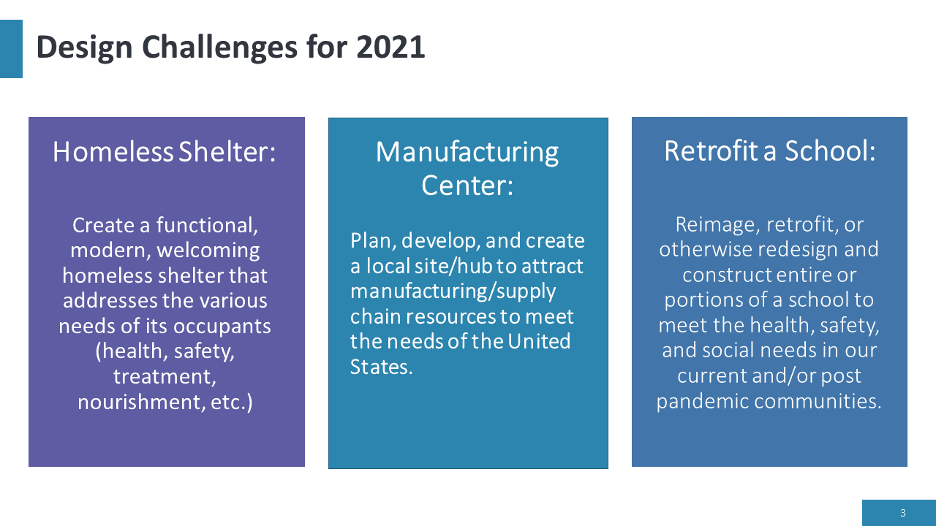
SPECS for Project Options/Challenges (select one RFP for the competition):
Manufacturing Center/Zone
Plan, develop, and create a local site/hub or zone to attract manufacturing, supply chain resources or other like elements to meet the needs of the United States to recapture or reclaim its competitiveness in the global market. As the nation begins the process of recovering from the COVID-19 pandemic and shutdowns, what has become apparent to many is the necessity to bring back “on-shore” the lost capacity and assets to secure vital supply chain elements to our most important products and services. To accomplish this paradigm shift will take the design AND construction of modern, multi-model, accessible, energy sufficient, and worker friendly areas or zones where manufacturing facilities or hubs can rise to meet the challenge. Part of this development will mean connectivity and community through the application of ingenious planning, design, AND construction solutions. This project option calls upon the teams to delve into rethinking how we apply our assets to bring about a renaissance in manufacturing and jobs on U.S. soil. Critical to success teams must demonstrate: (1) the paramount importance of your site selection [before vs. after site development], (2) the critical elements to undertake your plans, (3) how use of materials/construction creates the necessary attraction or value to your site, (4) balance of functionality and design, (5) environmental impacts, security, and construction approaches, and (6) provide a cost estimate (per foot) to address the needs that is realistic and doable for the resources/financial support likely available in the locale. Due to the likely displacement and logistical problems this project will create in a community, the proposal MUST include the precise CONSTRUCTION steps, stages, demolition, and remedies for these problems.

Homeless Shelter
Create a functional modern welcoming homeless shelter that addresses the various needs of its occupants such as: medical/health, safety/security, hygiene, nourishment, drug/alcohol treatment, etc. The challenge is to apply design AND construction techniques or applications that will create an inviting environment that will attract the indigent and homeless to abandon their nomadic or street existence for something more nurturing and secure found in a homeless shelter. The teams are encouraged to think outside the box and propose creative solutions to this vexing problem. The entries must connect or capture in the “built environment” (including structures, landscaping, building materials, techniques, and overall presentation) as the elements of a successful homeless shelter. The proposal must determine the site selected (a critical element and why), the size of the undertaking (both in terms of structures, land use, and access) [Provide before vs. after site development]; as well as provide a CONSTRUCTION timeline and per/sq. foot estimate of the cost of delivering the project. [The cost estimates must be realistic and doable for the resources/financial support likely available]. The entry should strive to be a catalyst or model for use around the country to address the issue of homelessness on our streets.
Retrofit School
Reimage, retrofit, or otherwise redesign and re-construct areas or portions of (and possibly entire) schools to meet the health, safety, and social needs in the current AND post pandemic environment. With the rise of concerns and debate around reconvening in-person school attendance (at the elementary, secondary, and college levels); a heightened awareness and need to reimage or rethink indoor educational spaces has become paramount. In this spirit, the entry must use construction materials and approaches that will provide spaces that will balance, comfort, and/or calm fears or concerns regarding reasonable health concerns; so that proven in-person educational instruction, as well as the other ancillary valuable social exchanges critical for mental health and wellbeing can transpire and be achieved. The team entries must demonstrate: (1) the precise aspects or areas of your applied solution (i.e., what portions of the school and why you chose them), (2) how use of materials and construction solutions address the challenge, (3) balance of functionality and design to achieve the project goals, and (4) provide a cost estimate (per foot) to accomplish the needs in a realistic and doable way consistent with the resources/financial support likely available in the locale. [The proposal MUST also include the precise CONSTRUCTION steps, stages, and remedies for this challenge, with any demolition or other pre-retrofit work described and detailed].

