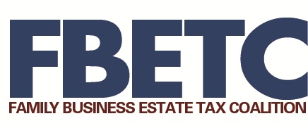

March 27, 2023

The Honorable John Thune
U.S. Senate
511 Dirksen Senate Office Building
Washington, D.C. 20510

Dear Senator Thune:
On behalf of the Family Business Estate Tax Coalition (FBETC), thank you for introducing the Death Tax Repeal Act of 2023 to permanently repeal the estate tax.
Historically, the FBETC has supported increased estate tax exemption thresholds indexed for inflation, permanent lower tax rates, and provisions for spousal transfer and stepped-up basis. Additionally, the FBETC supported the temporary estate tax relief in the Tax Cuts and Jobs Act (TCJA), which doubled the exemption to approximately $12.9 million for tax year 2023 and indexed future increases for inflation through 2025.
These changes represent significant relief to family-owned businesses from the estate tax. However, without further congressional action, the temporary increase in the exemption amount will expire at the end of 2025, increasing uncertainty and planning costs. While the FBETC supports making the estate tax provisions of TCJA permanent, the FBETC continues to believe that repeal is the best solution to protect all family-owned businesses from the estate tax.
Thank you for your continued efforts to support America’s family-owned businesses and farms. We look forward to working with you to advance this important issue.

Sincerely,

